- Given the root of a binary tree, return the level order traversal of its nodes' values. (i.e., from left to right, level by level).

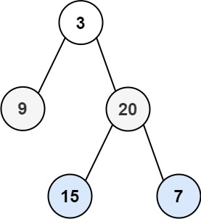

Solution:

public List<List<Integer>> levelOrder(TreeNode root) {

List<List<Integer>> result = new ArrayList<List<Integer>>();

if(root == null){
return result;
}

Queue<TreeNode> queue = new LinkedList<TreeNode>();
queue.offer(root);

int size = 0;
while(!queue.isEmpty()){

List<Integer> levelNode = new ArrayList<Integer>();
size = queue.size();

while(size--) {

//Extract the front element from the queue
TreeNode peek = queue.poll();
levelNode.add(peek.val);
//Check if the left child is null or not
if(peek.left!=null){
queue.offer(peek.left);
}
//Check if the right child is null or not
if(peek.right!=null){
queue.offer(peek.right);
}
}//while loop closed

//Add the nodes in each level to the result
result.add(levelNode);

}// while loop closed

return result;

} //function closed

TC: O(n)
SC: O(n) where n is the number of nodes in the Binary Tree

- Given the root of a binary tree, return the average value of the nodes on each level in the form of an array. Answers within 10-5 of the actual answer will be accepted.
Input: root = [3,9,20,15,7]
Output: [3.00000,14.50000,11.00000]

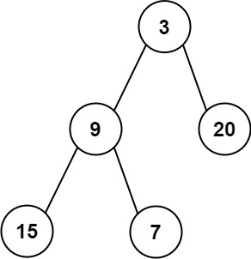

Solution:
public List<Double> averageOfLevels(TreeNode root) {
LinkedList<Double> ll = new LinkedList<>();
Queue<TreeNode> q = new LinkedList<>(); // in bfs we take queue to traverse one level completely

if (root == null) {
return ll;
}
q.add(root);
while (!q.isEmpty()) {
int n = q.size(); // here n is the level size or number of elements in level
double sum = 0.0;
for (int i = 0; i < n; i++) {
TreeNode node = q.poll(); // removing/polling a node
sum += node.val; // adding it to sum of the level

if (node.left != null) { // now again we will add remove node left and right to queue for next level calculation
q.offer(node.left);
}
if (node.right != null) {
q.offer(node.right);
}
}//for loop ends
ll.add(sum / n); // average value in the level
}// while loop ends
return ll;
}

TC: O(n)
SC: O(n) where n is the number of nodes in the binary tree.

- Given a binary tree
struct Node {
int val;
Node *left;
Node *right;
Node *next;
}
Populate each next pointer to point to its next right node. If there is no next right node, the next pointer should be set to NULL. Initially, all next pointers are set to NULL.

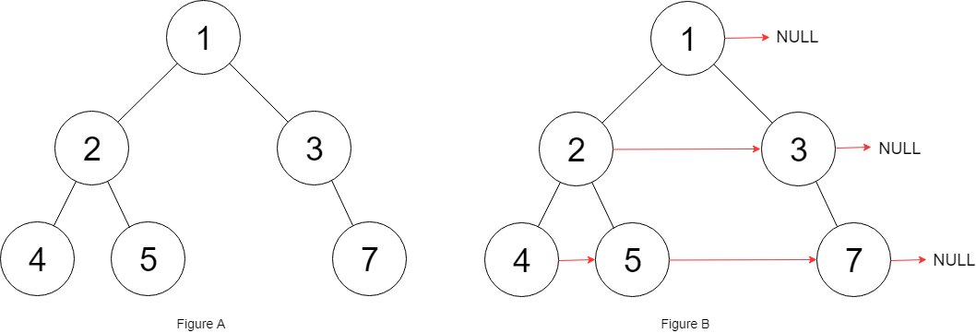

Solution:

public Node connect(Node root) {
//check for null input
if(root == null)
return root;
//make a queue for bfs
Queue<Node> queue = new ArrayDeque<>();
queue.add(root);
//going through the nodes in the queue
while(!queue.isEmpty()){

int size = queue.size();
//size denotes the number of elements belonging to the current level in tree
for(int i=0;i<size;i++){
Node curr = queue.poll();
//if the node is not the last node in its level
if(i<size-1) curr.next = queue.peek();
//add the left and right child to the queue
if(curr.left != null) queue.add(curr.left);
if(curr.right != null) queue.add(curr.right);
}//for loop closed

}// while loop closed

return root;

}//function closed

TC: O(n)
SC: O(n) where n is the number of node in the tree

- Given the root of a binary tree, return the zigzag level order traversal of its nodes' values. (i.e., from left to right, then right to left for the next level and alternate between).
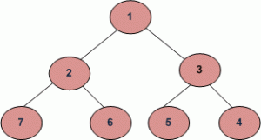

Output: zigzag order traversal will be 1 3 2 7 6 5 4.

Solution.
public List<List<Integer>> zigzagLevelOrder(TreeNode root) {
List<List<Integer>> result = new ArrayList();
if(root == null)
return result;

Queue<TreeNode> q = new LinkedList();
q.add(root);
boolean isLevelOdd = false;
while(q.size() > 0) {
int size = q.size();
List<Integer> level = new ArrayList();
while(size-- > 0) {
root = q.poll();
level.add(root.val);

if(root.left != null)
q.add(root.left);
if(root.right != null)
q.add(root.right);
}// while loop closed
if(isLevelOdd)
Collections.reverse(level);
result.add(level);
isLevelOdd = !isLevelOdd;
}// while loop closed

return result;
}

TC: O(n)
SC: O(n)

- Print the left view of a tree.
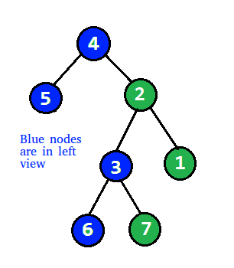
Solution:

private static void printLeftView(Node root)
{
if (root == null)
return;

Queue<Node> queue = new LinkedList<>();
queue.add(root);

while (!queue.isEmpty()) {
// number of nodes at current level
int n = queue.size();

// Traverse all nodes of current level
for (int i = 1; i <= n; i++) {
Node temp = queue.poll();

// Print the left most element at
// the level
if (i == 1)
System.out.print(temp.data + " ");

// Add left node to queue
if (temp.left != null)
queue.add(temp.left);

// Add right node to queue
if (temp.right != null)
queue.add(temp.right);

}//for loop closed
}//while loop closed
}//function closed

TC: O(n)
SC: O(n) where n is the number of nodes in the tree.

